# SELF-EXPERIENTIAL PROTOTYPING FOR AUGMENTED AND VIRTUAL REALITY OPERA CREATION

Taana Rose Dr Eve Klein Dr Fred Fialho Leandro Alves Teixeira

University of Queensland University of Queensland University of Queensland

## KEYWORDS

Opera, composition, technology, music, sound implementation, spatial sound, virtual reality, human-computer interaction, computer music.

## ABSTRACT

This paper explores prototyping as an iterative process to create virtual reality opera. I am drawing upon Human-Computer Interaction, spatialized sound, and games design methodologies to create new models for self-experiential prototyping. By fusing digital architecture, composition and extended reality (XR), as a composer, I am undertaking a creative process and investigative process, which is documented so that others can use it to learn to create new opera for a digital future. Sound is key to creating compelling virtual reality (VR) interactive experiences. Sound can aid immersion and add presence, as sound is a diegetic presence builder, sound is a navigation aid, sound adds believability, and sound can induce a mood. Music technology and extended reality opera creation techniques were used to create the opera XR *Artemis*. Autoethnographic prototyping methodology employs iterative models and written problem statements. The figures explain the steps needed for self-experiential prototyping to create new VR opera experiences.

## INTRODUCTION

In this paper, my VR opera *Artemis* is examined in detail via discussions of effective VR techniques and implementation. I consider how autoethnography can be deployed for successful prototyping, and how the design and implementation underpinning the creative development process for virtual environments have been utilised to stage my new extended reality opera *Artemis.* Making a VR opera entails the creator being multidisciplinary. Creating the virtual environment (henceforth VE) for *Artemis* brings together game design, architecture, game aesthetics, broad-brush prototyping, and precision to detail in creating comfortable and safe VR experiences for users.

*Unity3D*, a platform for 3D world creation, is utilised to create an Oculus VR version of the opera work for the *Oculus Quest*. *Unity Technologies* promote their product by describing how virtual reality heightens a creator's creativity in relating a narrative. They state that the creative opportunities are endless when a creator realises their imagination with the *Unity3D* canvas (Unity Technologies, 2020). The creator designs a world, which enhances the word-painting of each piece. This combination of word painting and world-building immerses the creator and audience member both sonically and visually. Peters et al. (2016) argue that *Unity3D* was the most adaptable and robust software to create VR and AR applications when their study was undertaken, which seems to correlate to present-day industry usage.

This paper will discuss the techniques that were used to increase the effectiveness of the extended reality opera prototyping, including 3D spatial sound as a cheap UI aid for graphics trade-off (Brenda Laurel, Atari research, 1980s). I am employing 3D spatial sound in my Oculus prototype development, by using the *FMOD* '3D object Spatializer' plugin on each audio event.

VR painting software for AR content creation and VR asset creation

I have experimented with painting the virtual environment models for the Oculus VR experience in *Tilt Brush* and importing my *Tilt Brush* painting into *Unity3D* with Poly, editing the virtual world in *Unity3D* and distributing it on the *Oculus Quest* to be experienced with the *Oculus* Link throughout all prototyping. The learnings that I am presenting in thos paper include self-experiential prototyping methodologies and models, as well as the creative processes employed as a composer-designer. These learnings may be useful for composer-designers who are looking to create their own extended reality productions.

## METHODS

I drew together the theories proposed by Schell (2020) to create my models for self-experiential prototyping (see figure 5 and figure 6). I also drew upon risk mitigation for game development methodologies; the idea behind risk mitigation is that the creator tries to reduce and eliminate risks to game enjoyment, to improve the game mechanics and effectiveness of the overall game experience. In the next section I will describe how this is achieved by building lots of fast and dirty small prototypes (Schell, 2020), this technique was implemented throughout 2020 and 2021 to create the first iterations of the opera *Artemis*.

Prototype creation

For each prototype iteration, I strived to find any barriers to the enjoyment of the VR experience, such as inaccurate head tracking in the Oculus VR experience and spawning in the incorrect position in the Unity build. I then eliminated these risks in the following prototype build. To prototype my VR opera, I employed risk mitigation and prototyping workflows.

I prototyped various different Greek-inspired virtual environments in *Unity3D* and the visuals inspired the music and vice versa. This fits into the light and sound architect Xenakis’ creative process of being inspired by music and mathematical formula visualisations to create architectural structures (Xenakis, 1992). I am inspired by visuals to create the music. I fuse virtual visual and sonic elements to create an opera set in Ancient Greece. Xenakis created a light bulb and laser work in 'Formalized Music' by employing the relationship between light and sound successfully, as each light bulb is a different frequency and pitch in the musical composition. In prototyping *Artemis*, the distance proximity of the spatialised audio in the Oculus VR version employs the relationship between light (visuals) and sound.

#### THE LENS OF IMMERSIVE OPERA

Composing for a medium such as virtual reality and augmented reality entails creating media-based immersion by creating set designs similar to film sets or immersive theatre. In future exhibitions of the Oculus version the additional staging elements are dry leaves collected and placed in the space, tactile sensory elements are incorporated to immerse the audience in the experience. Dry leaves are placed on a plinth and add the tactile and sonic aspects of holding autumn leaves whilst listening to the 'Autumn Ayre Aria'.

Whilst participants are in the spring environment listening to 'Licht und Liebe', sprayed rose water adds the sensory smell of roses. In the summer virtual reality environment for 'Mi amor la luna', a fan blowing warm air is placed in front of participants to create the immersive experience of being in a hot summer environment. In 'Winter Duet' particles of paper confetti are dropped onto the participant to create the tactile experience of falling snow. As the offboarding activity the audience member may take home any of these objects alongside their paper cut out onboarding object.

#### THE LENS OF COMPOSER AS RESEARCHER: THEMES IN WORLD CREATION, THEMES IN MUSIC

I composed the arias and duets using *Finale*; the scores were rehearsed and performed by the three performers, the work recorded in The Nickson Room. I then edited the recordings in *Ableton Live*, exported the audio files and imported the audio into *Unity3D* and *FMOD,* I split the recording of the entire opera into 4 parts and mapped each composition to a different vase for the Oculus version, essentially mapping audio to objects as sound sources.

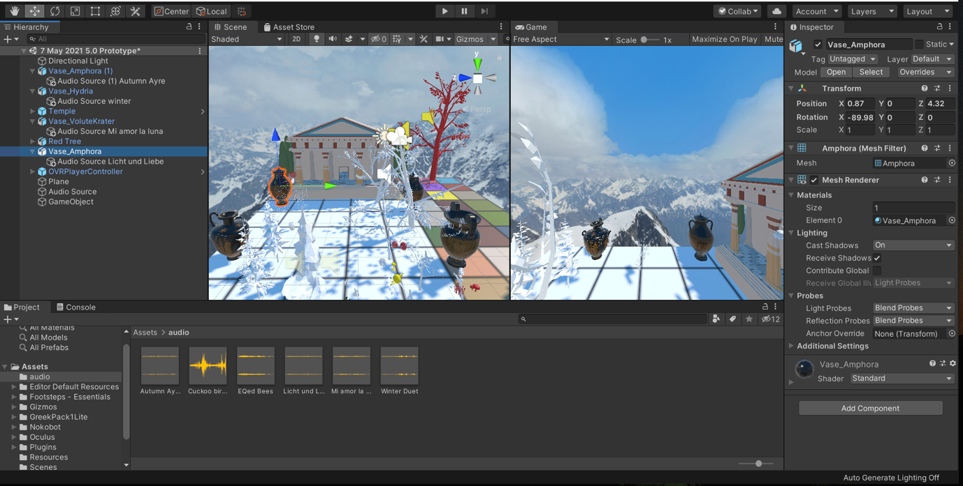

Vase Amphora and audio source set up for Licht und Liebe screenshot

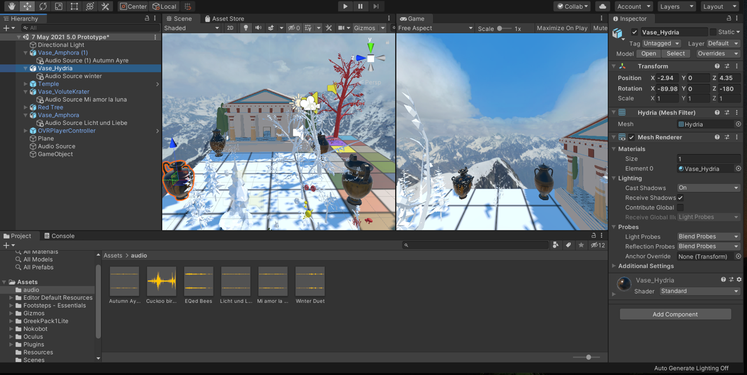

Vase Hydria and audio source set up for the Winter duet screenshot

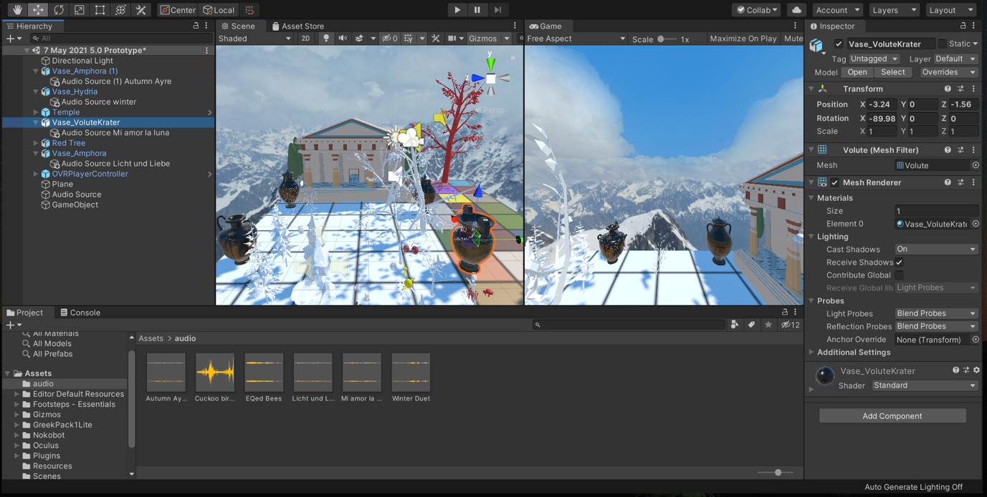

Vase VoluteKrater and Audio source set up for Mi amor la luna screenshot

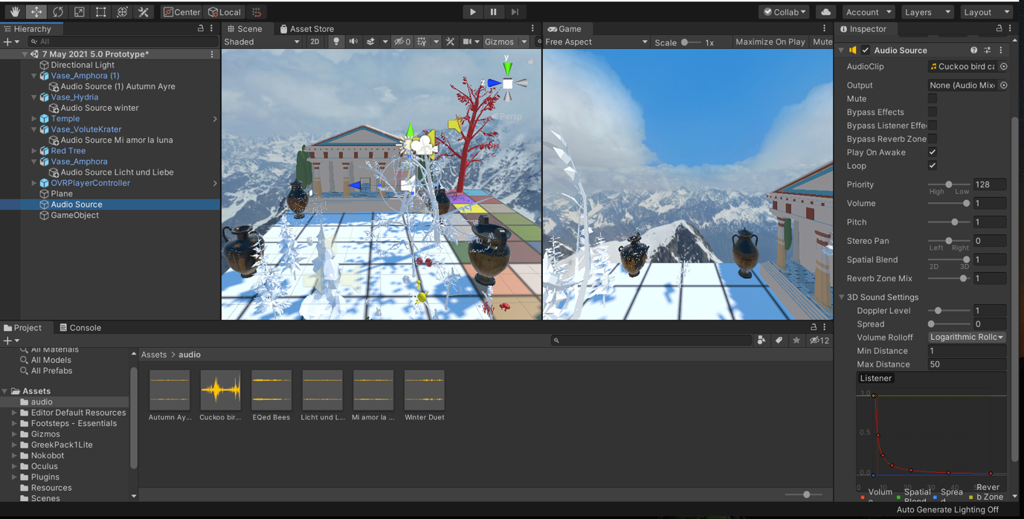

Cuckoo foley screenshot

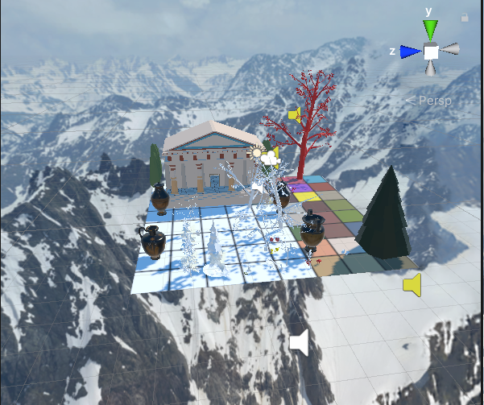

Artemis *Unity3D* skybox screenshot

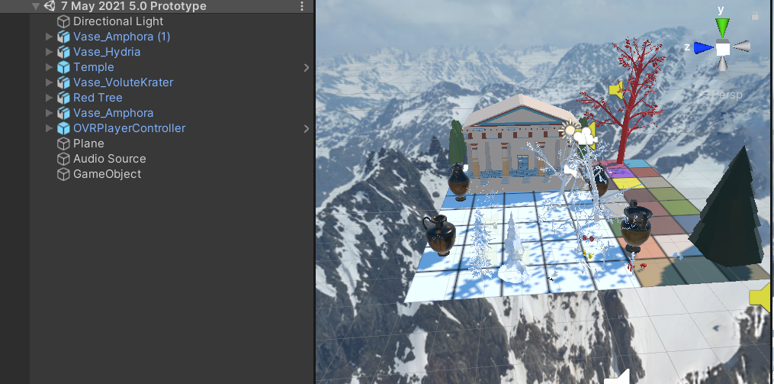

Game object hierarchy set up screenshot

I wrote each corresponding piece during this process, drawing upon the visual aspects and utilising word-painting, highlighting the different environmental factors of each season. Rationale: Seasons reflect nature, and the environment is a medium; this theme is realised visually and sonically in the compositional sonic and virtual worlds created.

Scale: idea transferred across mediums.

Scope: Performance design is vital with technologies. Virtual reality is a core component of the story. Virtual reality is a playful element.

*Artemis* comprises arias and duets utilising original German, English and Spanish libretto, with the mezzo-soprano as the central character.

In conclusion, *Artemis* is in the XR art experience category, the definitions of XR art and games are split in Screen Australia, thus I am drawing inspiration from video games, and XR art experiences are leveraged for *Artemis*.

The Oculus version of *Artemis* entails users roaming a plane containing a Greek temple and four vases:



Within the context of a non-linear opera, objects are interactable, and when the audience member touches an object, a fragment of the music is heard, the user controls how it is played back. The user is a live sound mixer, the user manipulation is simply proximity-based interactivity, the user changes which aria or duet is played back according to their proximity to the four vases. The high-level environmental sounds were mapped to the trees in the experience and the proximity of the user triggers the playback of the environmental bird call sounds. This is similar to the way that the spatial sound sources are mapped to each vase. Essentially the vase interactions and environmental sounds are all triggered by the user’s proximity to certain visual assets.

Creating and making assets and models of the visual experience in *Tilt Brush* gives deeper meaning to the creative process by creating in VR for VR. I am bringing in my perspective from the get-go by prototyping in VR in real-time, then importing my models into *Unity3D* and deploying the built virtual environment to the VR headset, which results in a cyclical artistic practice process in action formula for creating new Oculus VR music works.

Social presence is enhanced with virtual hands, which map to the users real hands; this is called hand presence. Virtual black hands have been created for hand tracking. 3D sound, spatial imagery and immersive 3D sound create an intimate sense of being there and aid in navigating spatially (Spillers, 2017).

VR development is examined in detail via discussions of effective VR techniques and implementation.

# RESULTS

The outcomes and learnings from my research include the development of new models and processes. My autoethnographic prototyping method employs iterative models which I created (figure 5 and figure 6). Figure 10 explains the steps needed for self-experiential prototyping to create new VR opera experiences.

Figure 6 helps structure the creators iterative VR prototyping process, as they systematically utilise the steps to create VR opera. By writing down the problem statement before building the VE in *Unity3D*, the creator has a methodology for designing a VR opera experience; solo testing in the VR headset follows on linearly. Utilising problem statements in an iterative loop is drawn from game design methodology. The testing of these problem statements forms a methodical way for creating a VR opera in a planned manner, the following six steps entail how you go about using problem statements in an iterative loop. The first step in action based, it is the act of doing, the second step is making, it entails building and refining your virtual environment in the *Unity3D* game engine. Step three entails you solo testing your experience, by putting on your VR Oculus headset and walking around in the virtual world which you have created. You then take the VR Oculus headset off and move to step 4, the act of reflection which entails thinking about and writing down what you believe could be fixed to make the experience of being in the virtual world better. This entails writing down a problem statement and testing again. The final step is asking for advice and feedback on your experience by consulting an expert.

Receiving expert advice entails receiving improvement suggestions and advice; this may be advice regarding spatial sound, asset use, interaction possibilities, tips on building functions to increase enjoyment through audio middleware and C# scripts.

I used *Tilt Brush* painting software, in which the artist is immersed in a 3D environment whilst painting. I created in the 360-degree medium and filmed and exported my work from this 3D environment. *Tilt Brush* allowed me to paint assets from scratch, which was an entirely iterative process, as I employed quick and dirty prototyping through experimentation, trial and error. I approached the autoethnographic journal by writing down problem statements (Schell, 2020). Fixing these problems via self-experiential prototyping means that whilst I was in the *Unity3D* build, I would walk around and move my head to see if it was an enjoyable experience for the user.

Additionally, I documented the steps for creating materials and wrote down issues that needed fixing in the next iteration of the prototype. The journaling methodology I employed was based on Schell’s (2020) methodologies. It was a free form journal without question prompts, rather I used headings of the six steps of the iterative loop. The relationship to the design processes helped me keep track of any changes that needed to be made to make better iterations.

Reflections upon lessons were journaled systematically. For example, one journal entry described the learnings for prototyping "learnt from Michelle Brown that the most stable *Unity3D* version for VR development is 2019.4.20f1".

The steps employed to create successful builds were journaled, the entries included the elements used in each prototype. For example, learning which *Unity3D* software workflow works best for prototyping: "including one of the *Artemis* rehearsal mp3 files. Firstly building the models and text in *Tilt Brush*, then importing these fbx model files into *Unity*3D utilising tilt-poly-toolkit-v1.0.4.unitypackage Releases · mwellck/tilt-poly-toolkit-unity (github.com).This prototype is a stationary experience with one audio source playing as the soundtrack, a starry skybox complements the *Tilt Brush* models".

The aspects to be created and implemented in the following prototyping session were subsequently journaled. For example, one journal entry described what the next steps would be in my iterative loop prototyping "Next up will be creating head tracking in the experience and mapping different audio segments to different objects in the *Unity3D* project".

DIARY ENTRIES:

VR Test 15 April

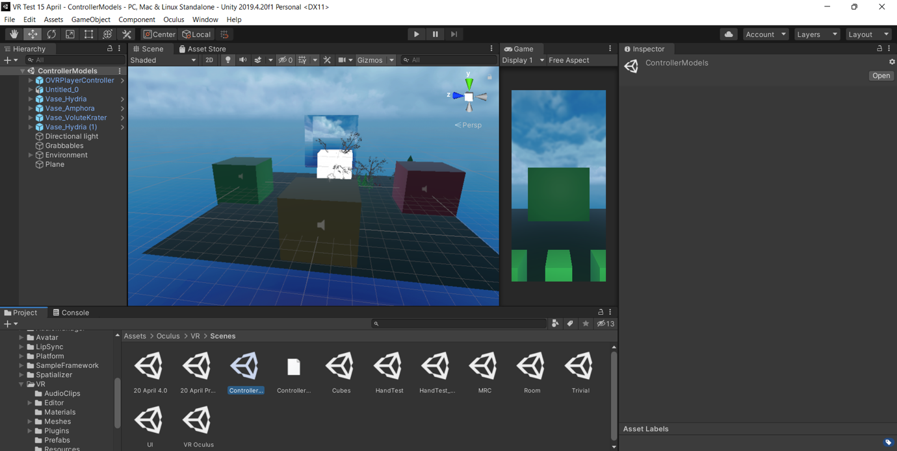

Idea generation

I added audio sources to the game object cubes in Unity to correspond to high-level sounds from each season:

1. Winter is a white cube; the audio source is 'Waves_Wind.'

2. Spring is a green cube; the audio source is 'cuckoo_bird_call.'

3. Summer is a yellow cube; the audio source is 'EQed Bees and Cicadas (Summer)'.

4. Autumn is a red cube; the audio source is 'SFX leaves falling for Autumn of Artemis'.

I utilised spatial blend: 3D, logarithmic, Maximum Distance: 50.

Initial development

Problem statement 1: Can the user pick up the cubes and hear the corresponding audio file?

Reflection and refinement

The build was successful; however, the 'ControllerModels' VR scene sees you inside a 3D cube/room, which was quite claustrophobic and different from expected. I made the top cube with wooden material in *Unity3D*; for the second test, I am testing it again with the top cube (which is essentially the ceiling) as an open skybox material so that the user in the VR experience does not feel so boxed in.

*Finalisation*

This test is much better as the sky is expansive, the 3D sound is working well.

*Testing, review and conclusions*

I am changing the 3D 'grabbles' game objects to have different colours. A key learning from this prototype is the limitation of the 'ControllerModels' VR Oculus Integration scene, as you are inside a cube, which does not afford for my open-world VR experience plan. Therefore, next, I am trying my custom-built scene utilising the 'OVRCameraRig' 'Plane' and 'OVRPlayerController' game objects. There is a Greek temple asset and Greek vase assets, the vase assets trigger audio. There are four trees; I have changed their material to correspond to each season, each tree is at a different corner of the plane, and when you walk towards a tree, you hear the corresponding aria. The user must collect vases to hear nature sounds from each season; each aria or duet is mapped to a different coloured tree.

This prototype is not quite right. The problem is that there is one compiler error in a C# Script from the *DreamForestTree* asset regarding recolouring (repainting) of the leaves, as I created my materials and repainted the leaves of each tree. I deleted the *DreamForestTree* assets and asset pack to rectify this issue.

I created another prototype with the ControllerModels *Unity3D* sample scene by moving the five cubes from the model apart to create a more open-world virtual environment. The key learning was that this was not the game aesthetic I was going for, as I wanted to use vases rather than cubes to create a more authentic Ancient Greek game world, this was the conclusion to take into the next prototype.

20 April Prototype

Initial development

I built one green plane, added four Greek vase assets at each corner of the plane, a Greek Skybox, an Artemis Temple in the middle of the plane, and the user must walk toward the different vases to hear the four different arias and duets.

Reflection and refinement

Head tracking is not set up correctly in *Unity3D*.

*Finalisation*

I built the scene in *Unity3D* and then put on the Oculus Quest headset to do self-experiential testing.

Testing, review and conclusions

While testing, the VE moved with my head; a key learning was that the head tracking was not set up correctly. The conclusion to take into the next prototyping stage was that I needed to re-read the Oculus developer online manual regarding headtracking.

21 April Prototyping Test 1

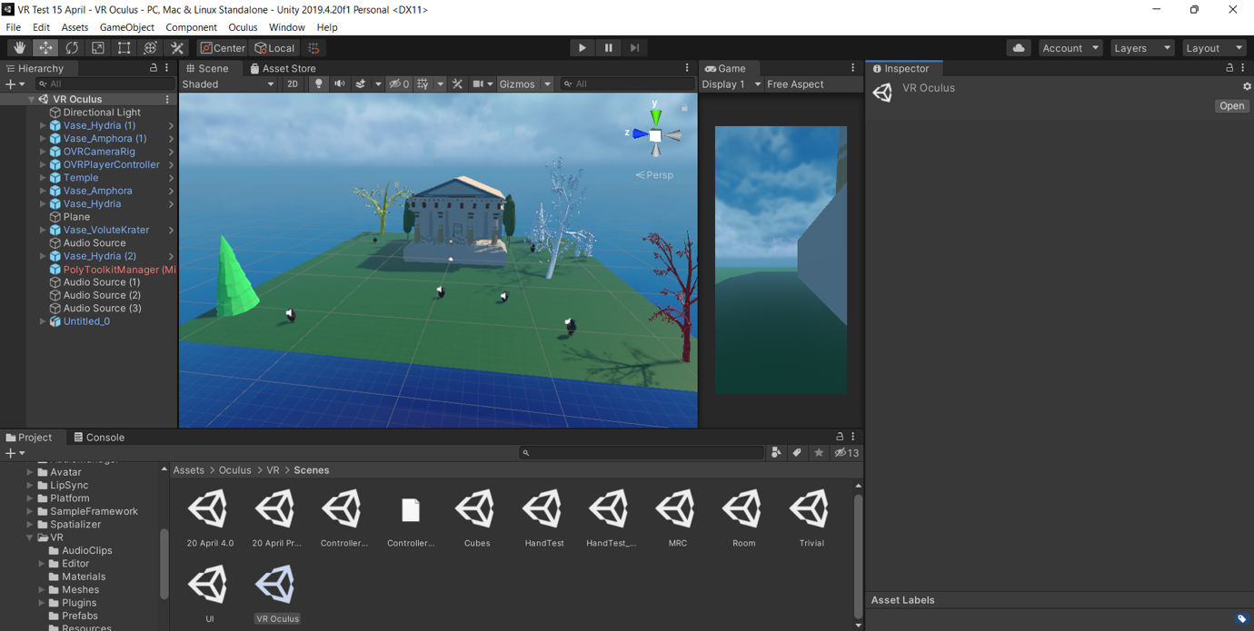

Initial development

I wrote down the problem statement: when I move my head in the Oculus Quest headset, the scene moves as well.

*Reflection and refinement*

To solve this problem, I looked at the elements in the VR demo scene 'ControllerModels' and compared it to my custom-built project. I realised that I had an extra 'OVRCameraRig', which I did not need, as the 'OVRPlayerController' already has a child OVRCameraRig included.

I tested the problem by removing the 'OVRCameraRig' from the hierarchy and building the scene.

Finalisation

It works, and I can successfully walk around with head tracking and locomotion; the 3D sounds work well, the VE is realistic with the Greek skybox filled with snow-covered hills and blue skies mottled with clouds.

*Testing, review and conclusions*

Problem statement:

I edited the scene for testing to have the temple at a realistic scale size; it is best to have the plane at 2 x 2 x 2. To take into my next prototype, I moved the vases closer to the temple. A key learning from this prototype was that the vases are too far apart; the plane's 3 x 3 x 3 scale is a bit large for a room-scale experience; so, I will reduce it to 1 x 1 x 1 and test this smaller scale. However, 1 x 1 x 1 may induce vertigo as the plane may be too small with the Greek Mountain skybox for people with a fear of heights; the conclusion to take into the next prototyping phase is to try out this problem.

21 April Prototyping Test 2

Initial development

I wrote down the problem Statement: the audio is not reactive.

Reflection and refinement

To fix the problem statement, I looped the audio source, made the audio source setting: Spatial Blend 3D and Maximum Distance 50.

Finalisation

I moved the vases to match up with the name of each aria which I painted in running cursive in Tilt Brush.

*Testing, review and conclusions*

A key learning was matching arias with visual models to create audio-visual cohesion in the virtual environment.

The user will then walk towards each vase and the corresponding text to hear each of the four arias/duets playback; the audio sources are mapped to the following:

· Licht und Liebe (duet) is mapped to Vase_Amphora

· Mi amor la luna (aria) is mapped to Vase_Volutekrater

· Autumn Ayre (aria) is mapped to Vase_Amphora [1]

· Winter (duet) is mapped to Vase_Hydria

21 April Prototyping Test 3

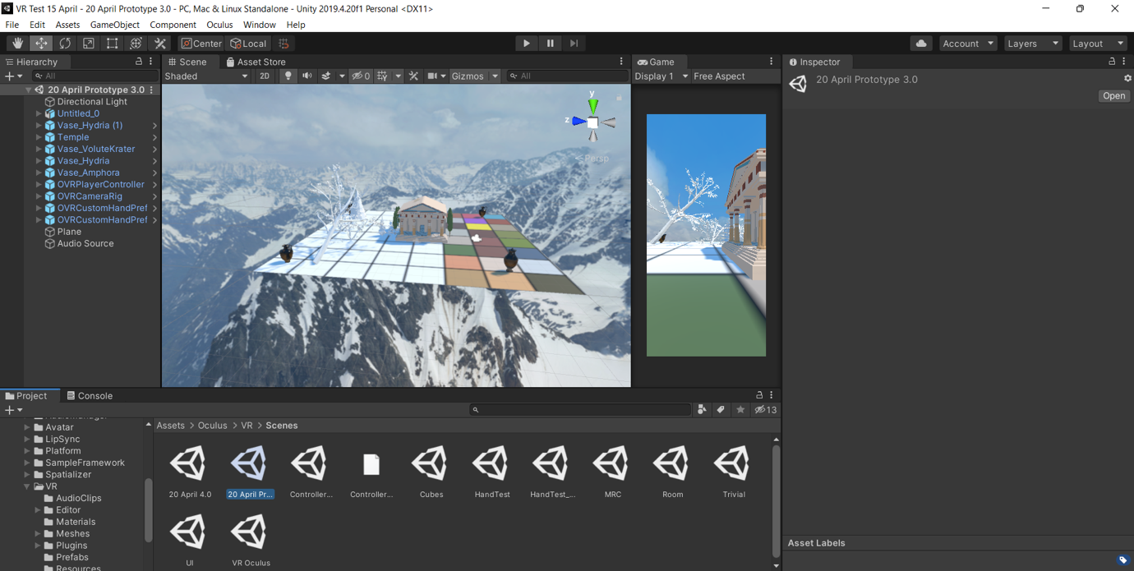

Initial

Initial development

*Test 3.1*

Whilst in the experience it is enjoyable.

Reflection and refinement

I wrote down the problem statement: The Autumn Ayre aria name text model is clashing with the Vase_Amphora [1] model; fix this by moving the vase asset ✓

Add audio sources to each vase. ✓

Problem statement 2: the *Tilt Brush* text is clashing with the vase asset

Fix the scale of Untitled_0 (my FBX model created in *Tilt Brush*) to make it bigger so that it does not clash with the vase asset ✓

*Finalisation*

*Test 3.2*

It looks excellent scale-wise while in the experience in the *Oculus Quest* headset.

Problem statement: the user begins the experience in the middle of a tree model. I fixed this by moving the OVRPlayerController asset to the middle of the vase area to begin the experience.

*Test 3.3*

Problem statement: The user starts in a position that is still too close to the tree models. I moved the OVRPlayerController again. I added a high-level audio source of cuckoo bird calls as ambient environment foley for the experience. I also added the audio recording from one of the opera rehearsals as a mock-up until the complete opera is recorded.

*Test 3.4*

Everything is working as it should; it is a realistic interactive VR experience.

*Testing, review and conclusions*

The key learning from these tests to take into the next prototype is:

1. Problem statement: there are no virtual hand controllers/gloves in the experience; these shall be added in the next prototype, as having virtual hands increases immersion in VR experiences (Interaction Design Foundation, 2021).

17 May prototype

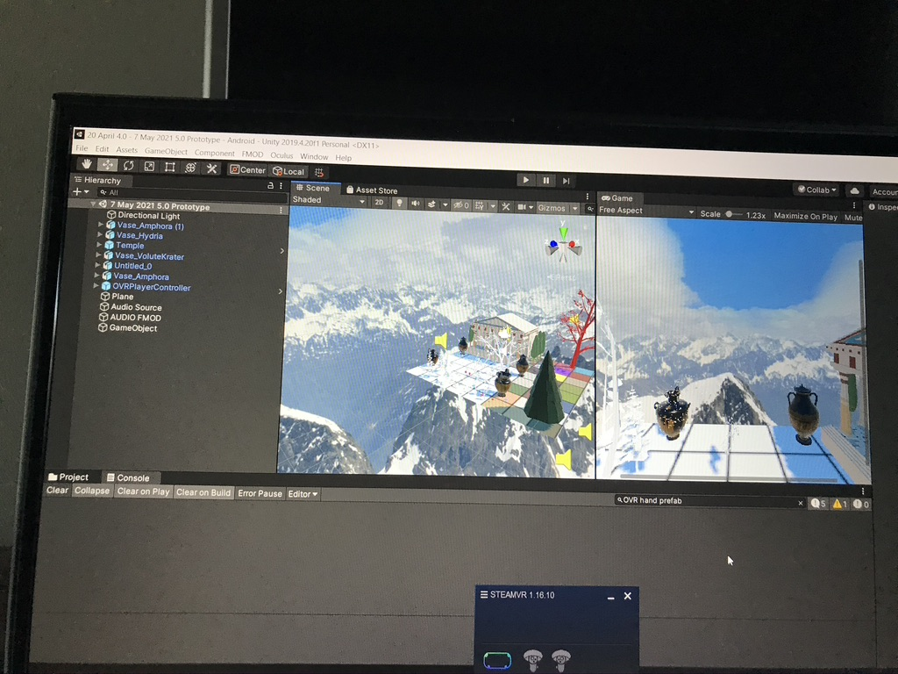

Initial development

I implemented the virtual hands successfully after the following troubleshooting:

Problem statement 1: I found that the virtual hands face the user's body upwards over the physical forearm; thus, they face the wrong way. To rectify this issue, I followed the steps outlined on the *Oculus* developer’s website *Hand Tracking in Unity Oculus Developers* to set up hand tracking accurately.

*Reflection and refinement*

Problem statement 2: One feels as if they are hovering in space as I changed the plane ratio to 1x1x1; thus, I went back into *Unity3D* and moved the OVRPlayer game object to the centre of the plane to rectify this issue.

Finalisation

Problem statement 3: I tried using a dial from the 'VR Buttons and Levers' pack from the Unity asset store; however, this encountered build errors due to compiler errors in the scripting. To rectify this issue, I deleted the asset package and mapped the synth instrumental to the trees.

Problem statement 4: I am not sure how to create an audio switch container in *FMOD*. Despite googling resources, I will need to get expert advice.

*Testing, review and conclusions*

A key learning from this prototype to take into the next was: problem statement 5 the *FMOD* aria events may be clashing sonically with one another whilst one is in the VR headset. The audio switch container needs to be built alongside editing the distance attenuation in *FMOD* to rectify this issue. The VR experience works successfully untethered with the *Oculus Quest*, the tracking works well, and I can see the virtual hands. The hands pass through the virtual objects. I need to add physics colliders to the virtual hands or all the game objects for the next prototype.

I also learnt to make sure that the *SteamVR* app is open and running on the Alienware to track and play the experience on the Quest untethered successfully.

YOUTUBEVR ARTEMIS

I painted in the 360-degree VR environment in *Tilt Brush* for VR for the YouTubeVR version of *Artemis*. In *iteration #3* of the *YouTubeVR* experience I painted the tree of life to represent Artemis’ life:

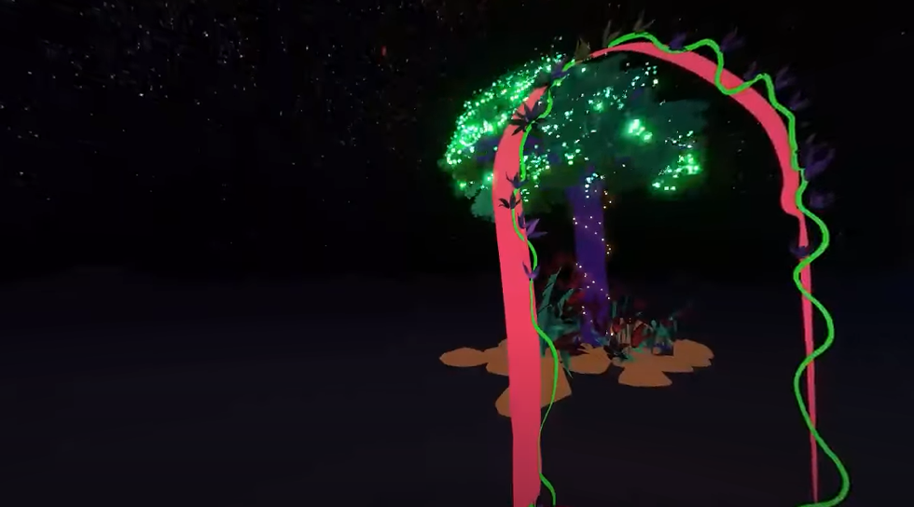

Colour changes were added to the render in *Adobe Premiere Pro* to add variation to the footage for each aria and duet.

With blue tones used for winter:

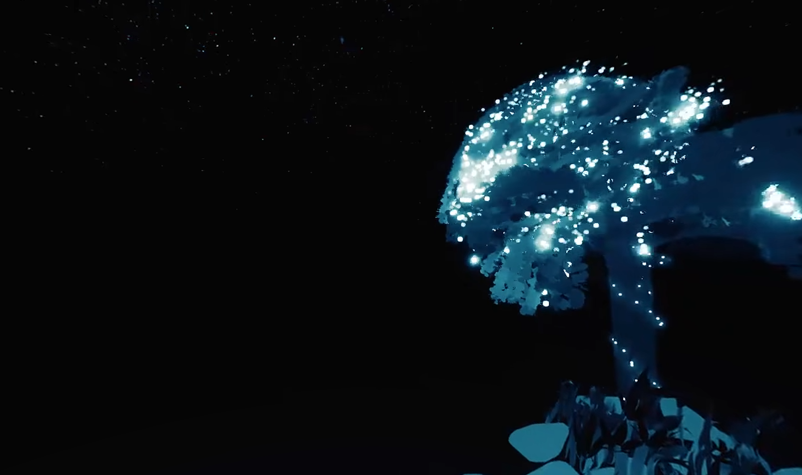

I made the footage black and white to highlight the nightscape for the aria to the moon ‘Mi amor la luna’:

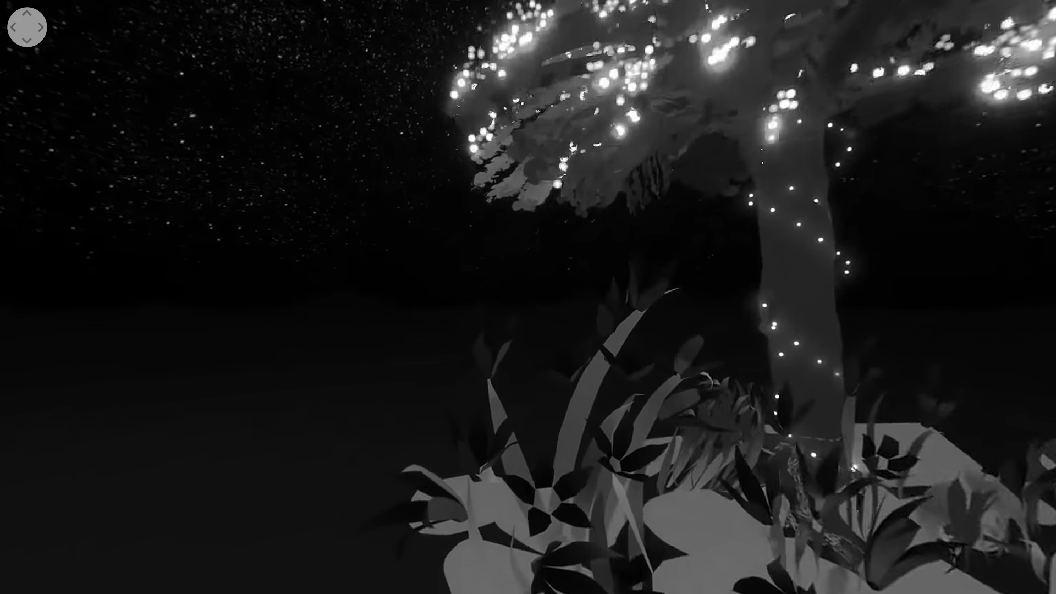

I added orange tones to the footage in *Adobe* *Premiere Pro* for autumn:

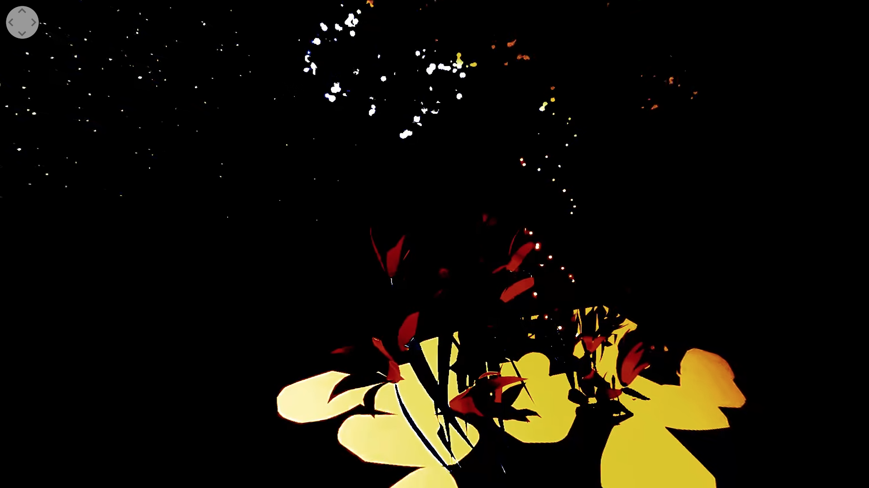

AR ARTEMIS

This section looks at the AR performance work, working with a mezzo-soprano operatic performer, an operatic tenor performer and pianist. This chapter also looks at the process of creating AR content by painting it in *Tilt Brush*, creating target images and QR codes and scanning these with a smartphone during the live performance. A performance video proof of concept is included in the Folio.

The AR 11 target images are painted in *Tilt Brush* and the QR codes are printed out and stuck on music stands for the forthcoming opera performance at BLOOM Festival. The target images overlay moving virtual images which are triggered with the spectators *EyeJack* mobile ARapp:

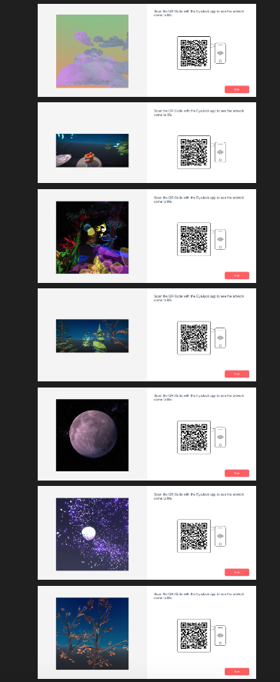

DISSCUSSION

People are increasingly making virtual operas, and opera's engagement with technology has expanded to match this interest. In the Australian context, the recommendations put forth in The National Opera Review (2016) highlight the current opera climate, namely, subsection 7.4, "Support the presentation of innovative works in collaboration with festivals" (p. 54), and subsection 7.5, "Increase the use of digital technology for innovation" (p. 55). This need for increased digital innovation in opera led to the operatic industry expressing increased interest in immersive projection, XR, and other digital media experience creation. The digital staging of opera works is increasing, with *The Ring Cycle* (Wagner, 1848) production by Opera Australia (forthcoming 2023), consisting of entirely virtual stages. Outside Australia, The *Current, Rising* (Fernando, 2020) production at The Royal Opera house shows a similar move towards “hyper-reality” (extremely realistic in detail, including virtual reality technologies). Both productions use virtual stages, which are considered easier to tour showing a trajectory of change within opera to incorporate new technologies and create novel mass-audience experiences.

My research compares the realisation of the same operatic text over various mediums as a vehicle for comparing the impact of different XR technologies on the process of opera creation from a composer’s perspective.

The implementation of these new workflows is documented through the design of models such as figure 5 and figure 6; these are visualisations of the same process outlined via two different lenses to explain how self-experiential prototyping methodologies can guide composer-makers to develop new works. Figures 5 and 6 model the workflows for designing extended reality opera works from the perspective of a solo creator responsible for all development stages; the maker goes directly from brainstorming to making, a novel way of rapid prototyping.

Figure 5 highlights how a composer-maker creator tests out a prototyping model, it is a systematic flow chart detailing the process for designing and prototyping a new extended reality opera by implementing self-experiential prototyping in a structured way. Step 1 entails the maker brainstorming the overall aesthetic of their opera through visualisation and note-taking. The maker moves directly from brainstorming to making a rough and ready virtual environment in *Unity3D*, moving between step 1 to step 2 by visualising their idea in the brainstorming phase and then picking up the technology and making it in step 2. After having built a rapid prototype, the maker moves from this step (2) to step 3 by taking a piece of paper and writing down a problem (step 3a) that the maker may experience which needs to be solo tested. In the VR headset (step 3b), after solo testing, the maker will find one problem that they have experienced while immersed in the rough software prototype and write down problem statement 2 to document what needs to be fixed (3c). The maker then moves between this step and the next by going into *Unity3D* and fixing the error (problem statement) in the backend of the software; after fixing this error to the best of the maker's ability, the maker puts on the VR headset and undertakes solo testing to see if the error was successfully fixed. The maker then moves from this step to the final step of getting expert advice by ‘building’ the *Unity3D* project and getting an expert to try out the VR experience in a headset such as *Oculus Quest 1*. Figure 5 is refined into the cyclical model of figure 6.

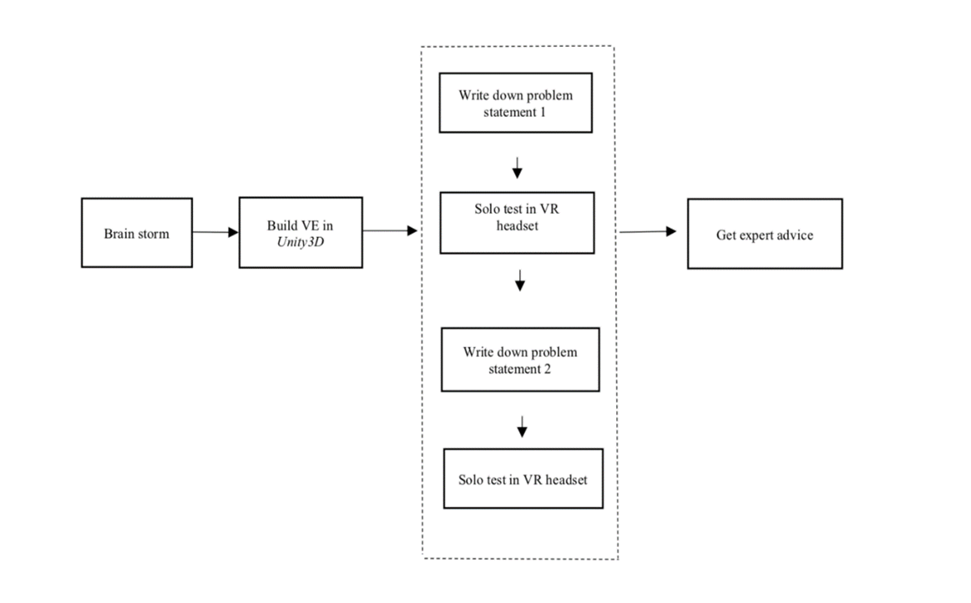

*Figure 5.* A structured and sequential self-experiential prototyping model of the prototyping process steps for Oculus prototyping.

Figure 6 details my journey through each stage of self-experiential prototyping. Smith and Dean's (2009) model states that academic research and creative practice are interwoven aspects of knowledge creation. Figure 6 emphasises the cyclical nature via arrows; this relates to Smith and Dean's Iterative Cyclic web model, in which Smith and Dean (2009) state that practice and research occur in a continuous cycle. This is seen in Figure 6; whereby continuous knowledge creation and testing encompasses the research projects' fundamental continuous cyclic nature. I have applied this premise throughout my research project, as the creative practice results in new models and processes for future research by other makers and scholars.

Figure 6 begins with writing down a problem statement that you want to solve, whereas Figure 5 begins with brainstorming. This highlights two different approaches and lenses for beginning prototyping, I utilised both in my project. Brainstorming is a broad-brush approach for experience creation. Problem statements entail that the maker has already begun testing and has found things to fix in the experience software.

Figure 6 represents the cyclical processes of self-prototyping; step 1 entails the maker writing down a problem statement that they want to solve. The maker then moves to make the software by building in *Unity3D*, or if it is a second iteration of the cycle, refining the virtual environment (VE) in *Unity3D.* The maker then moves from making the software to trying out the experience by solo testing in the VR headset (step 3). The maker then finds something that does not work well while immersed in the experience. They take the headset off and write down a second problem statement (step 4), then move between steps 4 and 5 by going back into the software and fixing the error identified in problem statement 2. Then the maker moves to step 5 of solo testing. Once the maker is happy with the fixed problem statements, they can 'build' the experience in *Unity3D* and ask an expert to watch the experience on a VR headset. Then the maker requests the expert to give constructive feedback on elements that need to be fixed. This constructive feedback is then used as a new problem statement for the next iteration of testing and leads to step 1.

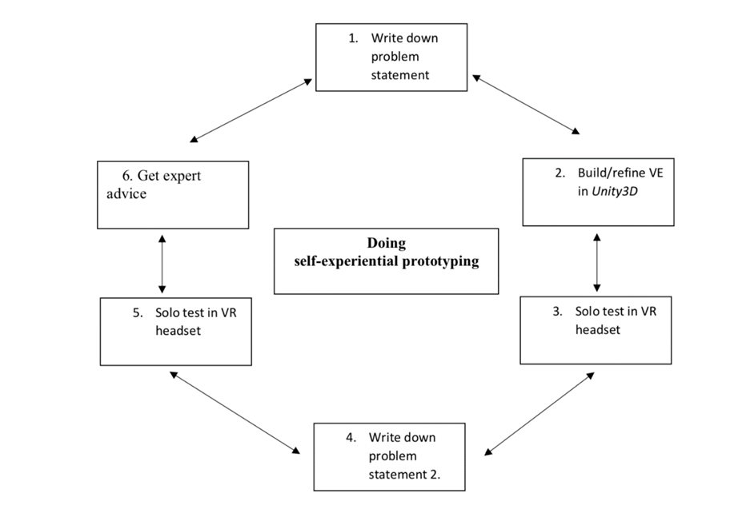

*Figure 6.* Doing self-experiential prototyping: an iterative cyclic model

## VIDEO AND AUDIO EXAMPLES

*Artemis* entails users being immersed in 360-degree environments, which correspond to the theme of each aria or duet. By creating and making assets and models of the visual experience in *Tilt Brush*, it gives deeper meaning to the creative process by creating in VR for VR. I bring in my perspective from the get-go by prototyping in VR in real-time; this results in a cyclical artistic practice process in action formula for creating new opera work.

Audio implementation in the Oculus version of Artemis:

DOI: 10.5281/zenodo.5748640

<https://zenodo.org/record/5748640#.YahLNb1BxQI>

Artemis DOI: 10.5281/zenodo.5748649

<https://zenodo.org/record/5748649#.YahO0L1BxQI>

Artemis Mi amor la luna VR

DOI: 10.5281/zenodo.5748659

<https://zenodo.org/record/5748659#.YahTJL1BxQI>

### DISCUSSION

The AR and VR environments are interactive with the Oculus VR work employing *Oculus Quest* hand tracking, the *YouTubeVR* version using headtracking, and the AR work utilising mobile interaction on the *EyeJack* AR app. These different approaches cater for world building (VR) versus place making (AR). Each version is interactive in a different way, the *YouTubeVR* version is interactive through its headtracking which changes according to where the audience member looks and audience members are encouraged to walk around the space to change their perception of the space; the impact of this is a feeling of immersivity, the effect is a total feeling of being there. The *Oculus* version is more interactive than the *YouTubeVR* version, as it builds upon it; headtracking is used in both, however hand-tracking is only used in the Oculus version. The impact is that the audience member controls the playback order of different areas triggered by the proximity of the hand-tracking to each of the four vases in the Oculus version, the effect is a gamified musical experience for the audience member. The AR version is interactive through the singer physically guiding the audience member into the performance hall and prompting them to scan a poster to download the AR app, the impact is a smooth transition into the live AR experience, the impact is a feeling of immersiveness in a hybrid augmented performance world, the effect is being transported into a digital opera world.

# REFERENCES

Laurel, B. (2013). *Computers as theatre*. Addison-Wesley.

Peters, E., Heijligers, B., Kievith, J., Razafindrakoto, X., Van Oosterhout, R., Santos, C., Mayer, I., Louwerse, Max. (2016), “Design for collaboration in mixed reality: technical challenges and solutions”, *In 8th International Conference on Games and Virtual Worlds for Serious Applications (VS-GAMES)*, 1-7.

Schell, J. (2020). *The Art of Game Design: A book of lenses*. CRC press.

Smith, H., & Dean, R. T. (2009). Introduction: practice-led research, research-led practice-towards the iterative cyclic web. *Practice-led research, research-led practice in the creative arts*, 1-38.

Spillers, F. (2017, October). Soundspace: toward accessible spatial navigation and collaboration for blind users. In *Proceedings of the 5th Symposium on Spatial User Interaction* (pp. 158-158). Retrieved from: <https://dl.acm.org/doi/pdf/10.1145/3131277.3134921?casa_token=iLl49Lp8mPQAAAAA%3Aq9wDHle_XuWzAxMaC5BFSTR1VpcupfZmxMrG-uFh2Lys2-kpEy6T5tBVjeWxWRltKhiXBOH1yGfT>

*The National Opera Review.* (2016). Retrieved October 2, 2021, from <https://www.arts.gov.au/have-your-say/national-opera-review#:~:text=The%20Minister%20for%20the%20Arts%20released%20the%20National,the%20continued%20artistic%20vibrancy%20of%20Australian%20opera%20companies>.

Google Tilt Brush [Computer software]. (2022). Retrieved from <https://store.steampowered.com/app/327140/Tilt_Brush/>

Unity Technologies. (2020). Retrieved from

<https://unity.com/>

Unity3D [Computer software]. (2022). Retrieved from

<https://unity3d.com/get-unity/download>

Xenakis, I. (1992). *Formalized music: thought and mathematics in composition* (No. 6). Pendragon Press.